Small Business Network Design 3 switches
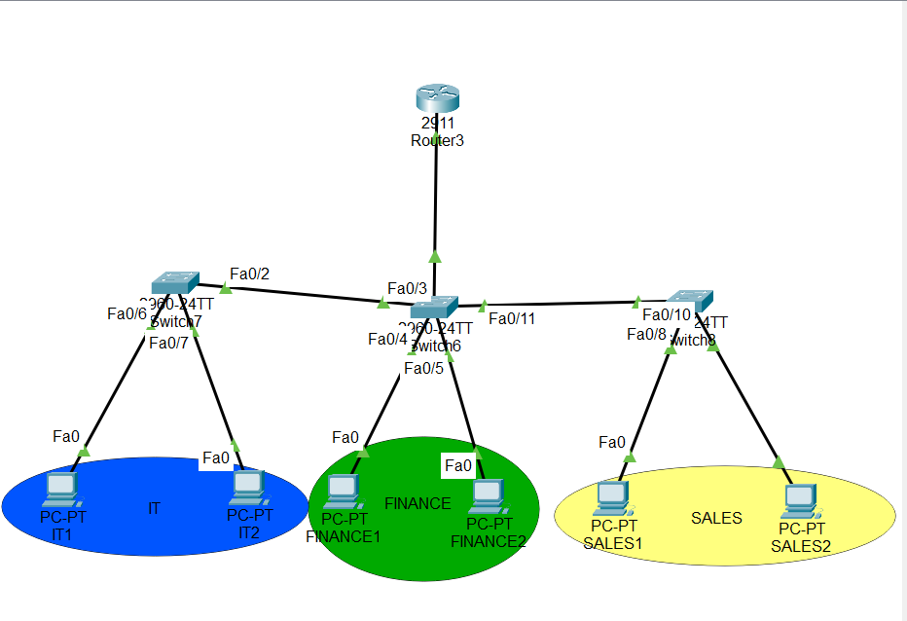
3 departments: IT, Finance, and Sales
- Add Network Devices and Identification with color codes
- 3 switches 2960
- 1 router 2911
- Pc(6)

- Connect Network Devices with copper straight-through cable.
- Assign IP Addresses and Default gateways

VLAN 10 (Finance): 192.168.10.100/24. VLAN 20 (IT): 192.168.20.101/24. VLAN 30 (Sales): 192.168.30.102/24.
- Determine IP Address Class and Subnetting
- A class C IP Address (Usually preferred for medium to small sized networks) and it ranges from 192.0.0.0 to 223.255.255.255.
Assign static IPs (e.g., 192.168.10.2) and set the Default Gateway to the router's sub-interface (e.g., 192.168.10.1).
- Router Config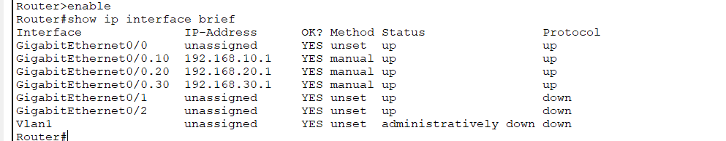
Configure Router-on-a-Stick.

- VLAN Setup
Create VLANs on all switches.
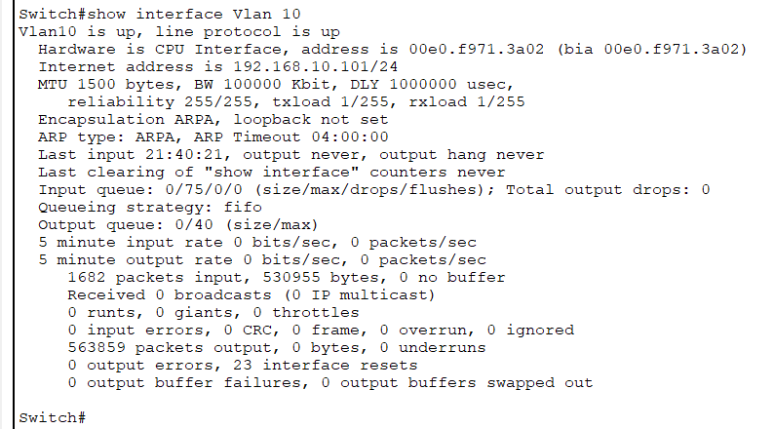

- Port Assignment
Assign PC ports to VLANs.
- Trunk Port
Configure ALL inter-switch and router links.
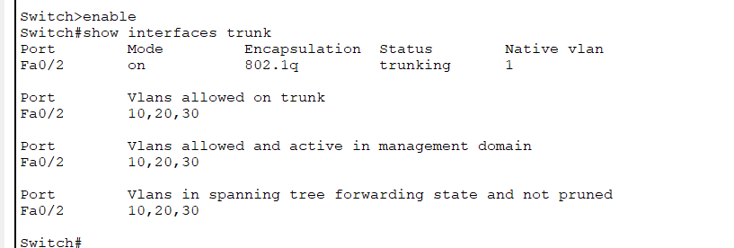
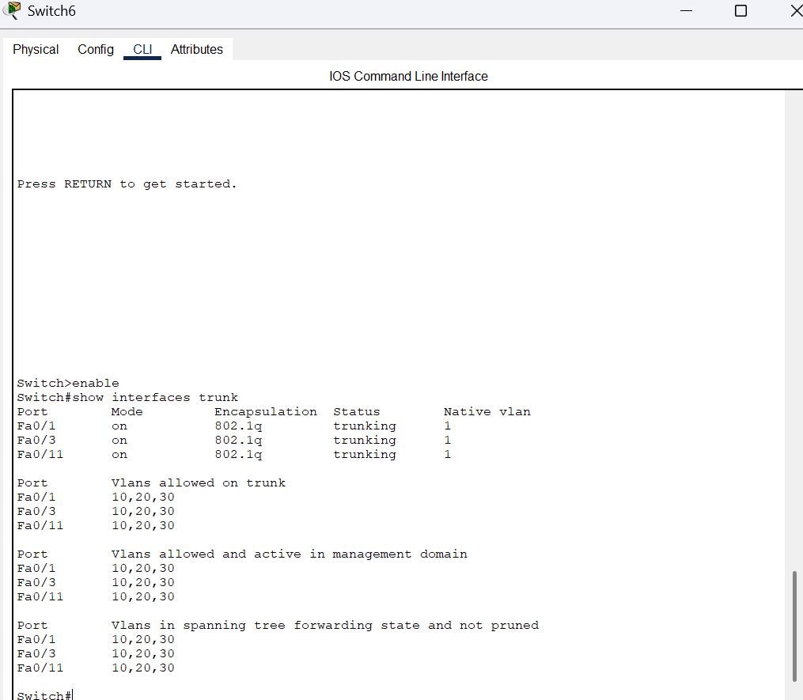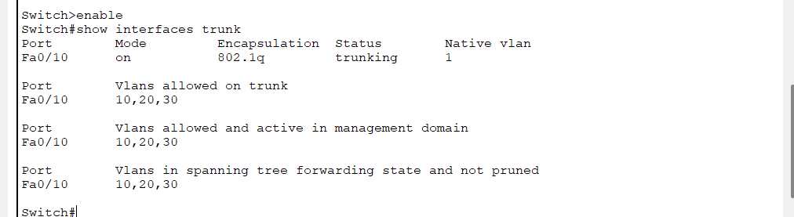

- Switch Management
Allow all three switches to communicate.
- Optimization
Eliminate startup delays.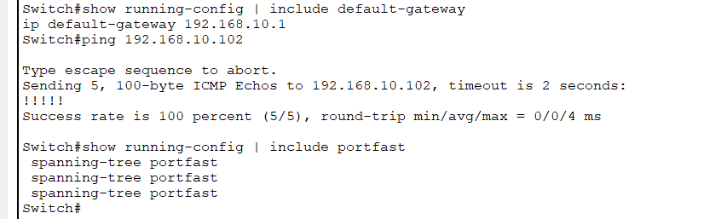
- Connectivity
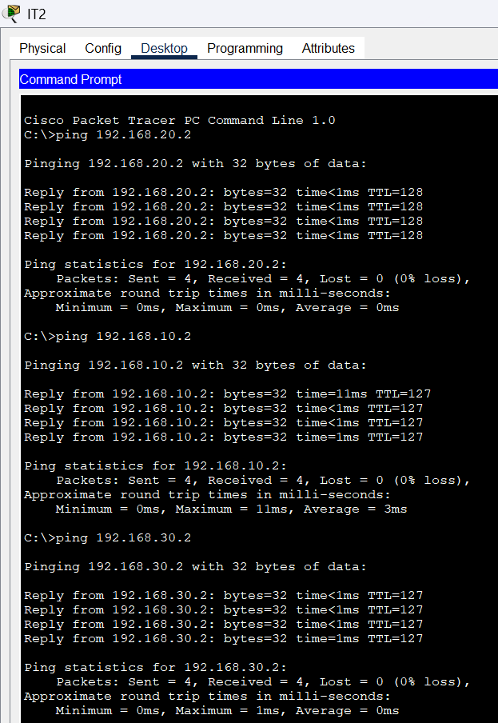
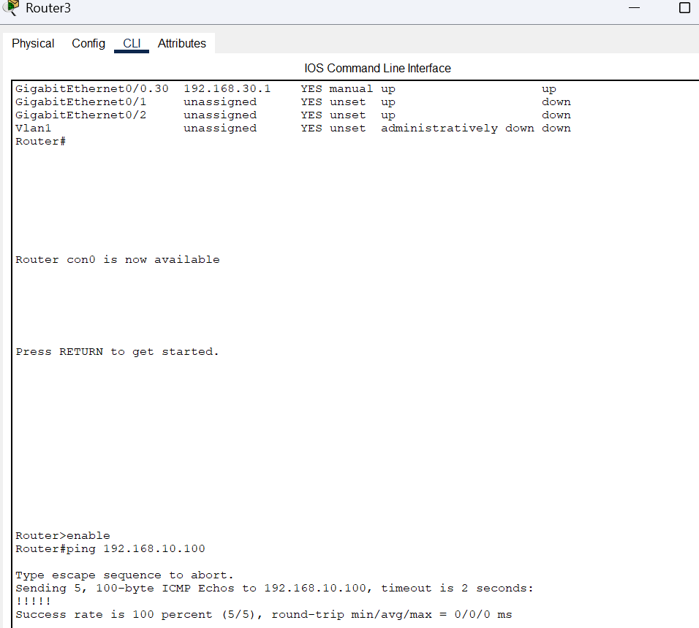

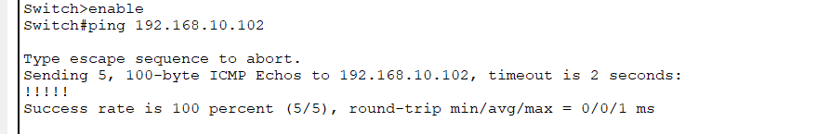

Worked by:Erinalda Loshi

